ADAM stands for Adaptive Moment estimation
The best optimizer and the most used is ADAM.
Adam combines the idea of MOMENTUM and ADAGRAD Optimizers.
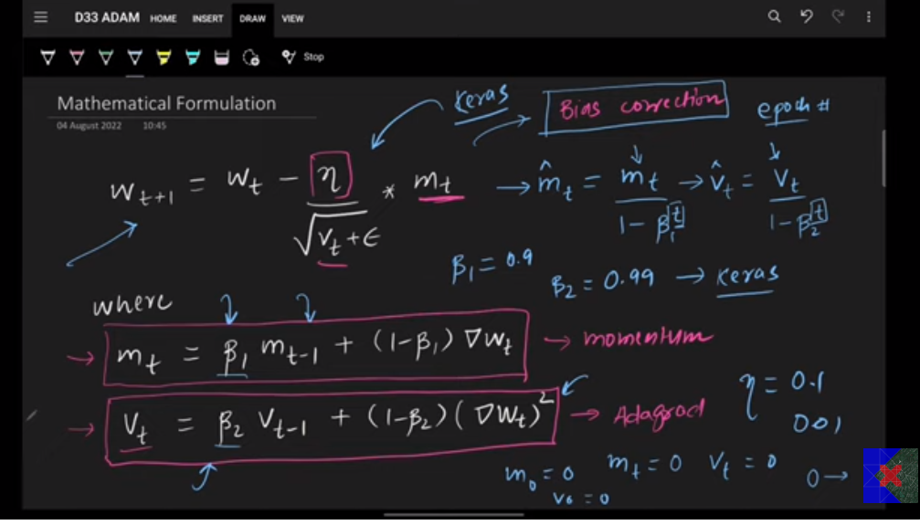

VERDICT:
Start with ADAM, whan with RMSPROP and than with momentum. DO hyperparameter tuning to find the best optimizer.

